DATABASE SYSTEMS ENGINEERING AND DISTRIBUTED BACKEND DEVELOPMENT

TOPIC: PHYSICIAN & DEPARTMENT TABLES

2520030371 – P. HAVISHAA REDDY

STEP 1: CREATE PHYSICIAN TABLE:

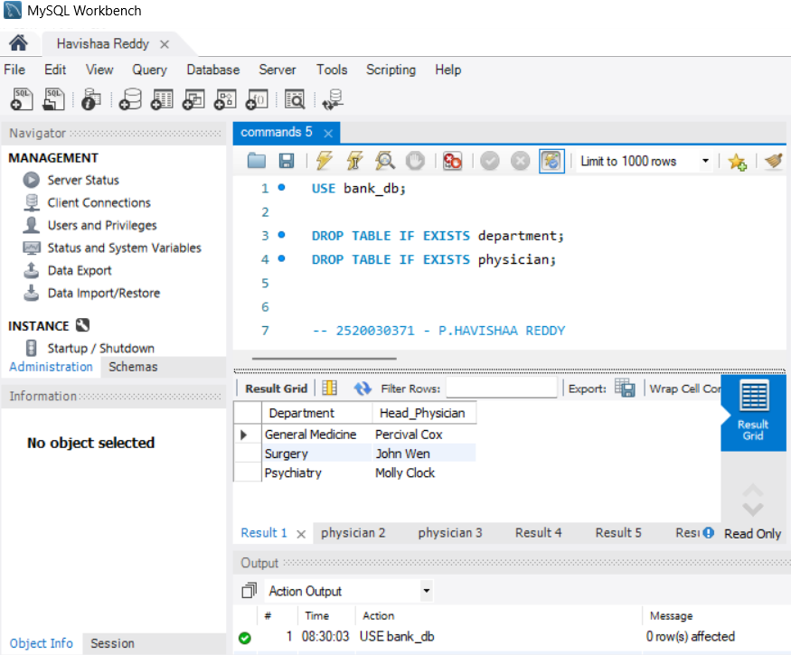

STEP 2: INSERT DATA INTO PHYSICIAN
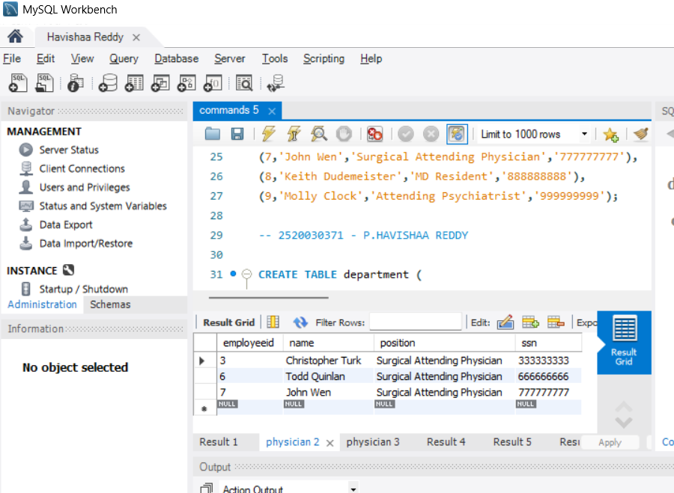

STEP 3: CREATE DEPARTMENT TABLE
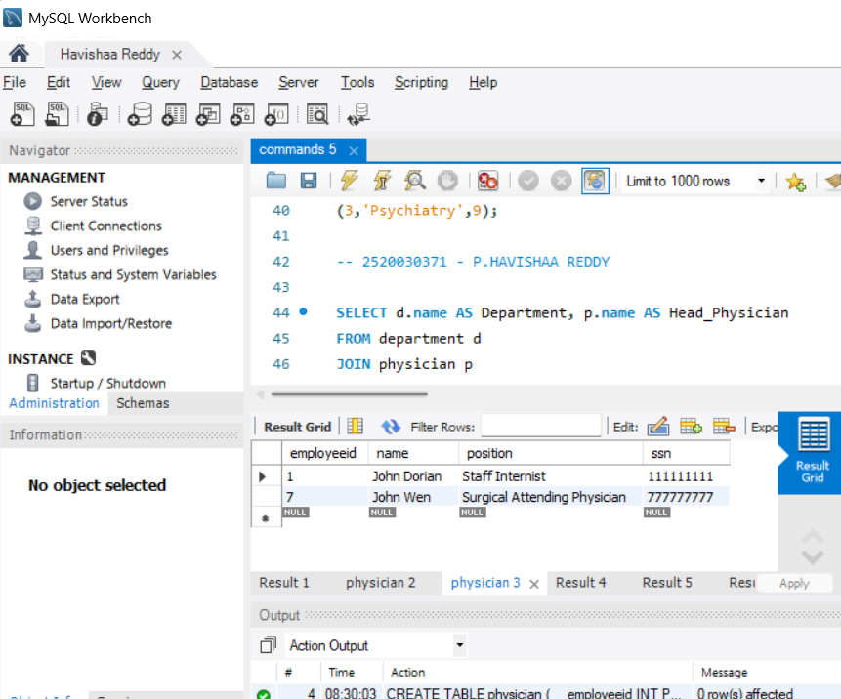
QUESTION 2 - WHERE CLAUSE

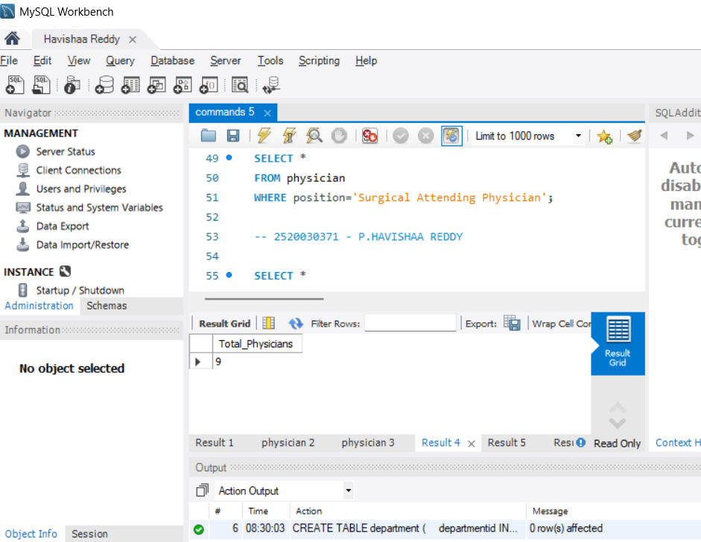

QUESTION 3 - WHERE + LIKE
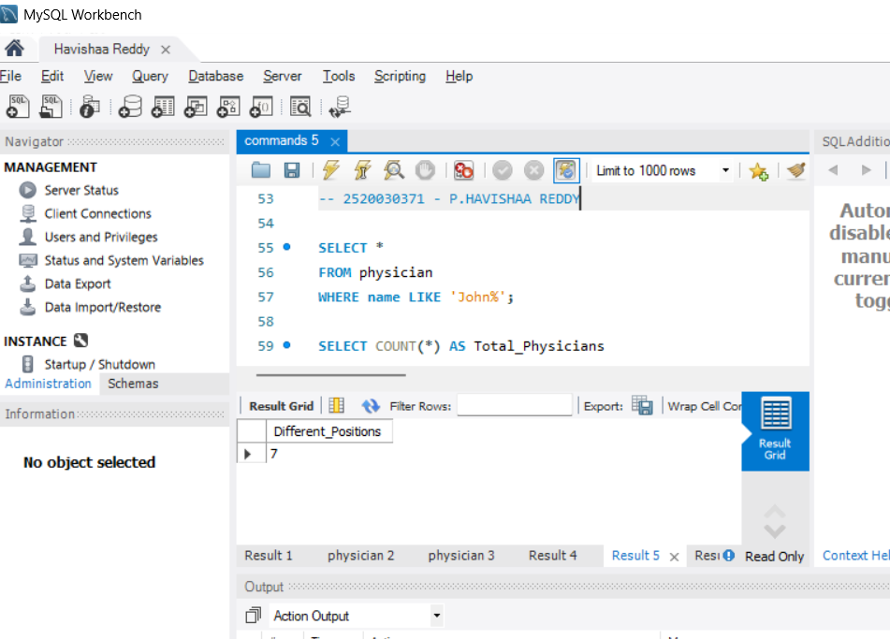
QUESTION 4 - COUNT()
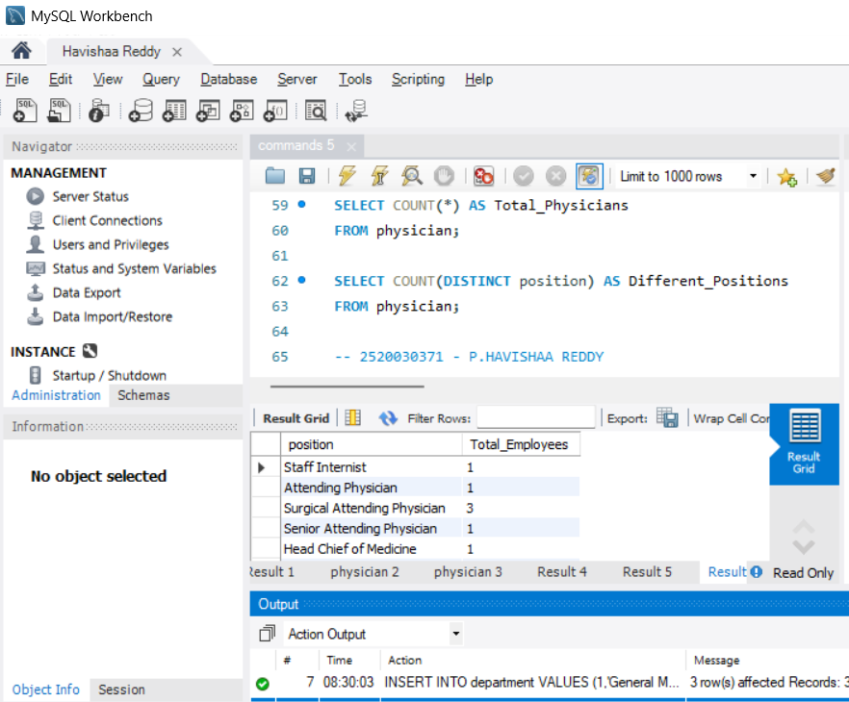

QUESTION 5 - COUNT DISTINCT
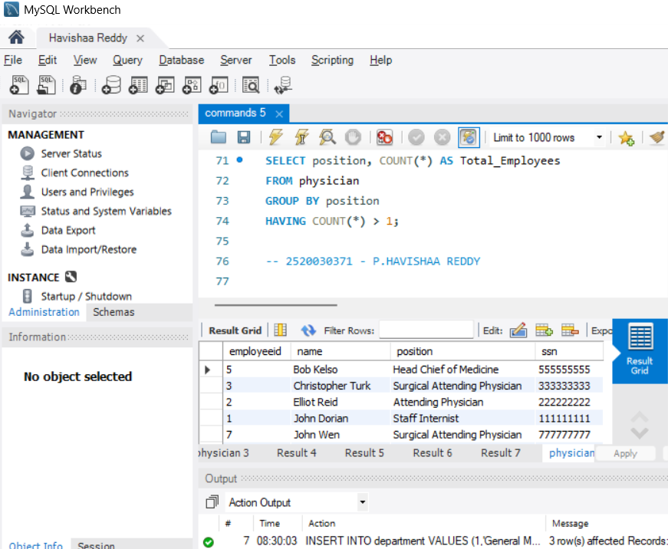
QUESTION 6 - GROUP BY
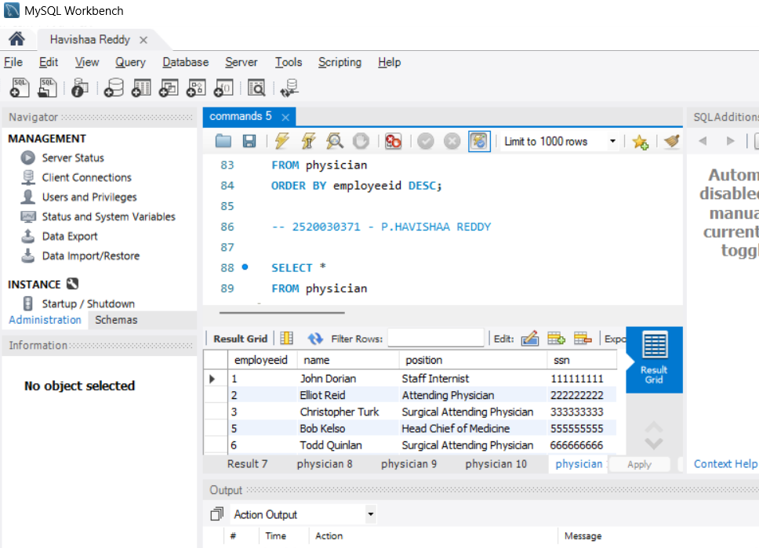

QUESTION - SUBQUERY
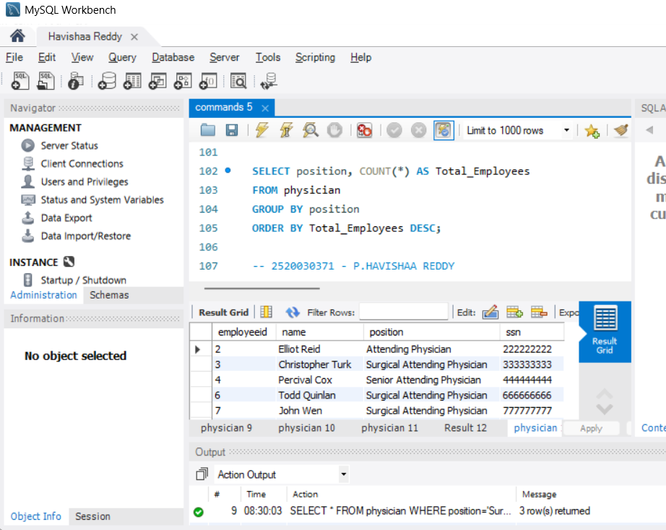
QUESTION - WHERE + LIKE
